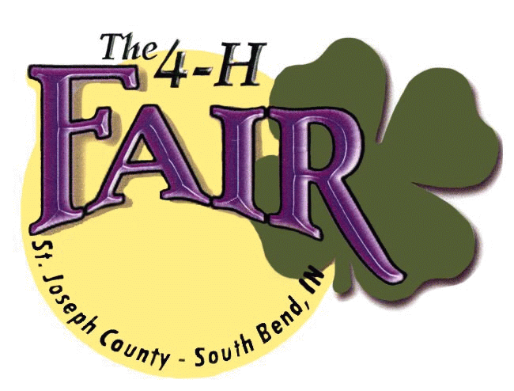
Indiana State Fair Youth Talent Contest
St. Joseph County 4-H Fair – Main Grandstands
Tuesday, July 5, 2022
Registration 5:00pm, Contest begins 6:00pm

Name of act / song: ________________________________________

Leader name: _____________________________________________ Email: ____________________
Signature: ________________________________________________
Address: _________________________________________________
City / State / Zip: ___________________________________________ Phone: ___________________
Please provide the following information about the contestant: (List all group contestants on back)
Name: ________________________________________________ Birthdate: _________________
Address: ______________________________________________
City / State / Zip: _______________________________________ Phone: ___________________
Contestants signature: __________________________________
Parent / Guardian: _____________________________________
Please check the appropriate category
Circle one: Junior Senior Circle one: Solo Group
Circle category:
Male Vocal Female Vocal Instrumental
Dance Novelty Tumbling (Free X only) Clogging

(Circle one) This act will be using a: CD ipod other: (please specify) ____________________
**Please note: Acts are to be 2 minutes or less**
*Submit completed applications to: 4-H Fairgrounds Attn: Rick Kring 5117 Ironwood Rd. South Bend, IN 46614, youthtalentcontest@4hfair.com

**Winners from each category (solo and group) will represent St. Joseph County at the Indiana State Fair in August, 2022. Contestants must confirm their ability to attend the state fair contest following the county contest on 7/5/2022.
Group Contestants
Name: ________________________________________________ Birthdate: _________________
Address: ______________________________________________ City / State / Zip: ______________________________
Phone: ________________________ Contestants signature: ____________________________
Parent / Guardian: (if participant is under 18) __________________________________________________________________
Name: ________________________________________________ Birthdate: _________________
Address: ______________________________________________ City / State / Zip: ______________________________
Phone: ________________________ Contestants signature: ____________________________
Parent / Guardian: (if participant is under 18) __________________________________________________________________
Name: ________________________________________________ Birthdate: _________________
Address: ______________________________________________ City / State / Zip: ______________________________
Phone: ________________________ Contestants signature: ____________________________
Parent / Guardian: (if participant is under 18) __________________________________________________________________
Name: ________________________________________________ Birthdate: _________________
Address: ______________________________________________ City / State / Zip: ______________________________
Phone: ________________________ Contestants signature: ____________________________
Parent / Guardian: (if participant is under 18) __________________________________________________________________
Name: ________________________________________________ Birthdate: _________________
Address: ______________________________________________ City / State / Zip: ______________________________
Phone: ________________________ Contestants signature: ____________________________
Parent / Guardian: (if participant is under 18) __________________________________________________________________
Name: ________________________________________________ Birthdate: _________________
Address: ______________________________________________ City / State / Zip: ______________________________
Phone: ________________________ Contestants signature: ____________________________
Parent / Guardian: (if participant is under 18) __________________________________________________________________
Name: ________________________________________________ Birthdate: _________________
Address: ______________________________________________ City / State / Zip: ______________________________
Phone: ________________________ Contestants signature: ____________________________
Parent / Guardian: (if participant is under 18) ________________________________________________________________

