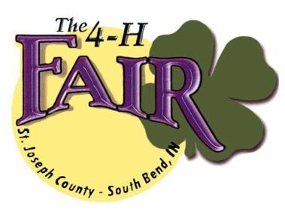
Friday, June 30th 2023
Line up: 4:30pm
Start: 5:30pm

Entry Form for St. Joseph County 4-H Fair Parade

Application Deadline: WEDNESDAY JUNE 14, 2023
Applications will NOT be accepted after this date.

EVERY ENTRY IN THE PARADE MUST SUBMIT AN APPLICATION
Applications can be emailed to: parades@4hfair.com
or mailed to:
St. Joseph County 4-H Fair Operations Office
Attn: Monica Cook
5117 South Ironwood Drive, South Bend IN 46614

NAME OF ENTRY:
CONTACT PERSON:
PHONE NUMBER:
ADDRESS:
CITY/STATE/ZIP:
E-MAIL ADDRESS:

______ MARCHING BAND ______ AMBASSADORS, ETC.
______ FLOAT WITH MUSIC ______ FLOAT WITHOUT MUSIC
______ HORSE UNIT ______ MOTORIZED VEHICLE/UNIT
______ MARCHING UNIT WITH MUSIC ______ MARCHING UNIT WITHOUT MUSIC
______ OTHER (DESCRIBE) ____________________________________________________

NUMBER OF PARTICIPANTS: ________

WE MUST HAVE A DETAILED DESCRIPTION FOR YOUR PARADE UNIT. DETAILED DESCRIPTION FOR ROYALTY RIDING IN CARS: NAME, CLUB & TITLE. THIS IS WHAT WILL BE READ WHEN YOUR ENTRY PASSES THROUGH THE GRANDSTANDS.

If you have any questions, please contact Rick Kring 574-273-0401/574-309-5486
or email: parades@4hfair.com

